**Annexure-II A**

**PART B (Outcomes after Execution)**

**Title: Application Launcher Using Advanced Java**

1. **Brief Description**

Java is a general-purpose computer programming language that is concurrent, class-based, object-oriented, and specifically designed to have as few implementation dependencies as possible. It is intended to let application developers “write once, run anywhere” (WORA), meaning that compiled Java code can run on all platforms that support Java without the need for recompilation.

For example, you can write and compile a Java program on UNIX and run it on Microsoft Windows, Macintosh, or UNIX machine without any modifications to the source code. WORA is achieved by compiling a Java program into an intermediate language called bytecode. The format of bytecode is platform-independent. A virtual machine, called the Java Virtual Machine (JVM), is used to run the bytecode on each platform.

Abstract Window Toolkit (AWT) is a set of application program interfaces ( API s) used by Java programmers to create graphical user interface ( GUI ) objects, such as buttons, scroll bars, and windows. AWT is part of the Java Foundation Classes ( JFC ) from Sun Microsystems, the company that originated Java. The JFC are a comprehensive set of GUI class libraries that make it easier to develop the user interface part of an application program.A more recent set of GUI interfaces called Swing extends the AWT so that the programmer can create generalized GUI objects that are independent of a specific operating system's windowing system .

Java Database Connectivity (JDBC) is an application programming interface (API) for the programming language Java, which defines how a client may access a database. It is a Java-based data access technology used for Java database connectivity. It is part of the Java Standard Edition platform, from Oracle Corporation. It provides methods to query and update data in a database, and is oriented towards relational databases. A JDBC-to-ODBC bridge enables connections to any ODBC-accessible data source in the Java virtual machine (JVM) host environment. DBC ('Java Database Connectivity') allows multiple implementations to exist and be used by the same application. The API provides a mechanism for dynamically loading the correct Java packages and registering them with the JDBC Driver Manager. The Driver Manager is used as a connection factory for creating JDBC connections. JDBC connections support creating and executing statements. These may be update statements such as SQL's CREATE, INSERT, UPDATE and DELETE, or they may be query statements such as SELECT. Additionally, stored procedures may be invoked through a JDBC connection. JDBC represents statements using one of the following classes:

Application software (app for short) is software designed to perform a group of coordinated functions, tasks, or activities for the benefit of the user. Examples of an application include a word processor, a spreadsheet, an accounting application, a web browser, an email client, a media player, a file viewer, an aeronautical flight simulator, a console game or a photo editor. The collective noun application software refers to all applications collectively. This contrasts with system software, which is mainly involved with running the computer.In information technology, an application (app), application program or software application is a computer program designed to help people perform an activity. An application thus differs from an operating system (which runs a computer), a utility (which performs maintenance or general-purpose chores), and a programming tool (with which computer programs are created) original research. Depending on the activity for which it was designed, an application can manipulate text, numbers, audio, graphics and a combination of these elements. Some application packages focus on a single task, such as word processing; others, called integrated software include several applications.

An application launcher is a computer program that helps a user to locate and start other computer applications. An application launcher provides shortcuts to computer programs, and stores the shortcuts in one place so they are easier to find.

Software that causes applications to load and run. Launching an app is naturally built into every operating system; however, third-party app launchers are available and popular for mobile and computer devices. An app launcher replaces the stock user interface for organizing the home screen and app icons predominantly in the computer world. We can open apps by just single clicking on them using mouse and applications will be loaded more faster than usual, hence application launcher is developed by us.

1. **Aim of Micro Project**
2. To learn Concepts of Advanced Java Programming such as swings, AWT, JDBC, etc.
3. To be able to create Graphical User interface applications using Advanced Java Programming
4. To store the input data into the database using Java Database Connectivity
5. Implementation of different AWT and swing components such as buttons, label, JFrame, etc.
6. To learn how to use different Java integrated development Environment such as NetBeans, Eclipse.
7. To open applications much fasted than usual
8. **Course Outcomes Integrated**
9. Develop a Program using GUI Framework (AWT and Swing)
10. Handle events of AWT and Swing Components
11. Develop a program to handle events in Java Programming
12. Develop program using Database
13. **Actual Procedure Followed.**
14. Make a Test case Plan and gather requirements for project such as images, Different software to be installed, and all resources.
15. Develop Login Form using NetBeans IDE:
16. Create a Graphical User Interface using Different Swing components such as Buttons, Text field, Labels, etc.
17. Add action event to the button using Event Listener interface in Java
18. Validate the Login form using the username as admin and password as admin in the action Listener
19. Test the Login Form and Open a new Frame after clicking the Submit button on Login form.
20. Develop an Application Launcher window using Sublime text:
21. Add the Heading as Application Launcher in the Window
22. Add Different buttons in the Application Launcher and add some layout to it
23. Add application images to the button and give action Event to the button
24. Call the external Applications using exec() command.
25. Test the application manually and note down the errors
26. Connect the Database to the Application NetBeans IDE
27. Import JDBC packages
28. .Load and register the JDBC driver.
29. Open a connection to the database.
30. Create a statement object to perform a query.
31. Execute the statement object and return a query result set.
32. Process the result set.
33. Close the result set and statement objects. Close the connection.
34. Test the application and make testcases.
35. **Actual Resources Used**

|  |  |  |  |  |
| --- | --- | --- | --- | --- |
| **Sr. No** | **Name of Resource/material** | **Specification** | **Qty** | **Remarks** |
| 1 | Computer System | 4 GB RAM, 500 GB HDD, i5 Intel Core Processor | 1 |  |
| 2 | Hardware Resources | Keyboard, Mouse | 1 |  |
| 3 | Chrome | Web Browser | 1 |  |
| 4 | Google | Search Engine | 1 |  |
| 5 | NetBeans IDE | Version 8.2 | 1 |  |
| 6 | Sublime Text | Version 3.2.1 | 1 |  |
| 7 | Microsoft word | 2018 | 1 |  |
| 8 | XAMPP server | Version 7.1.31 | 1 |  |

1. **Outputs of the Micro-Projects**

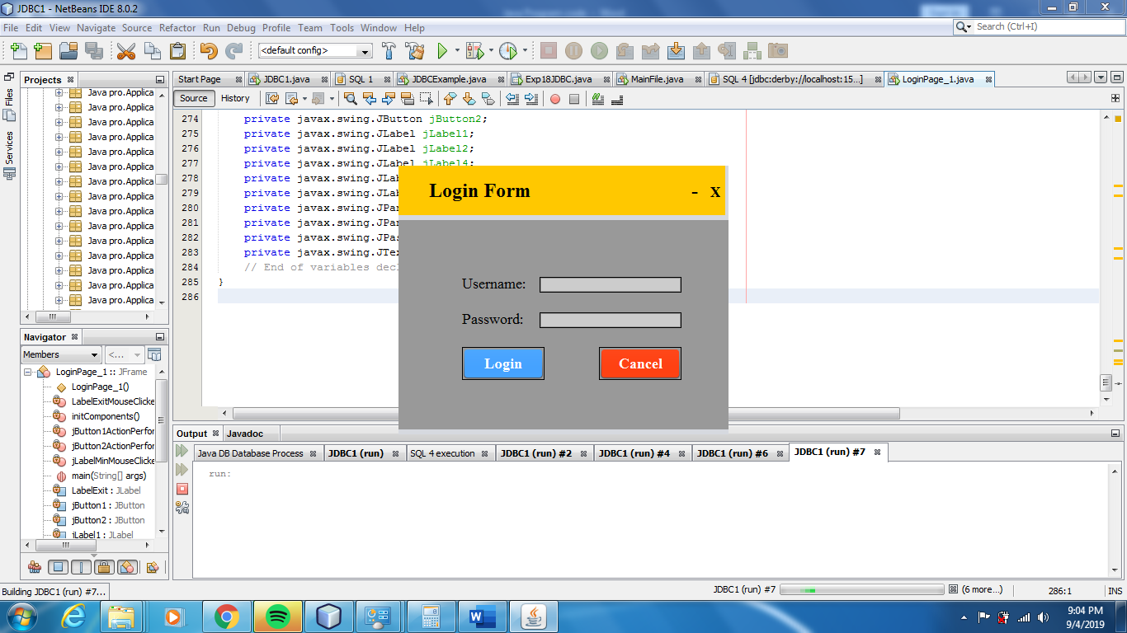

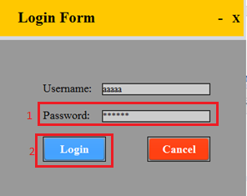 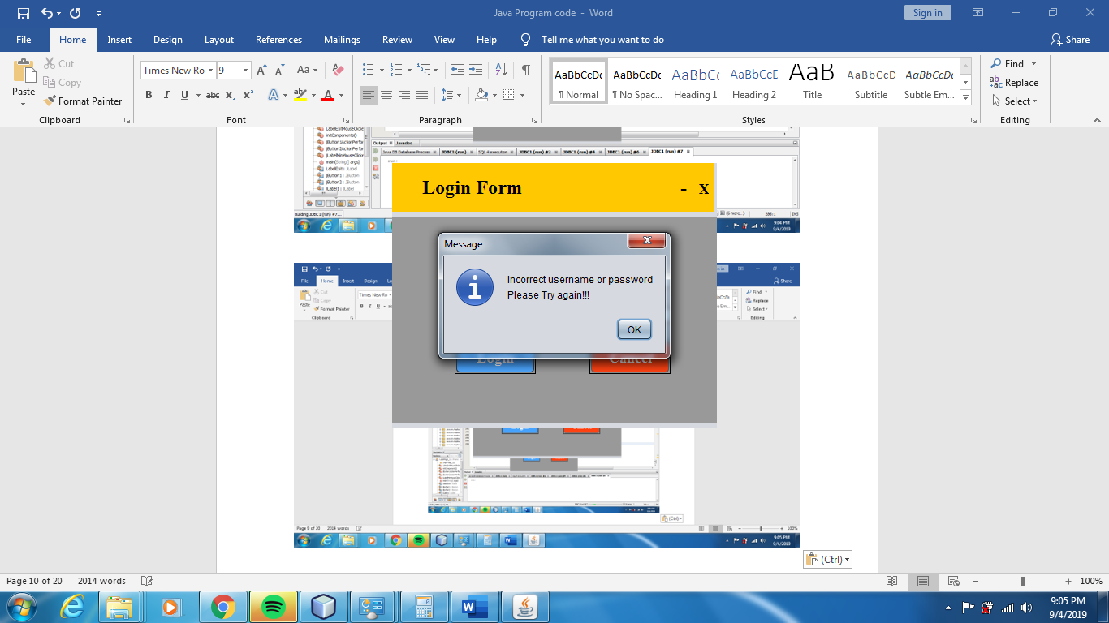

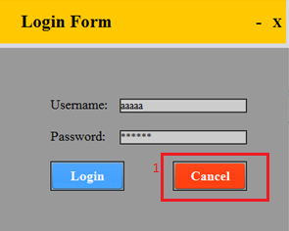 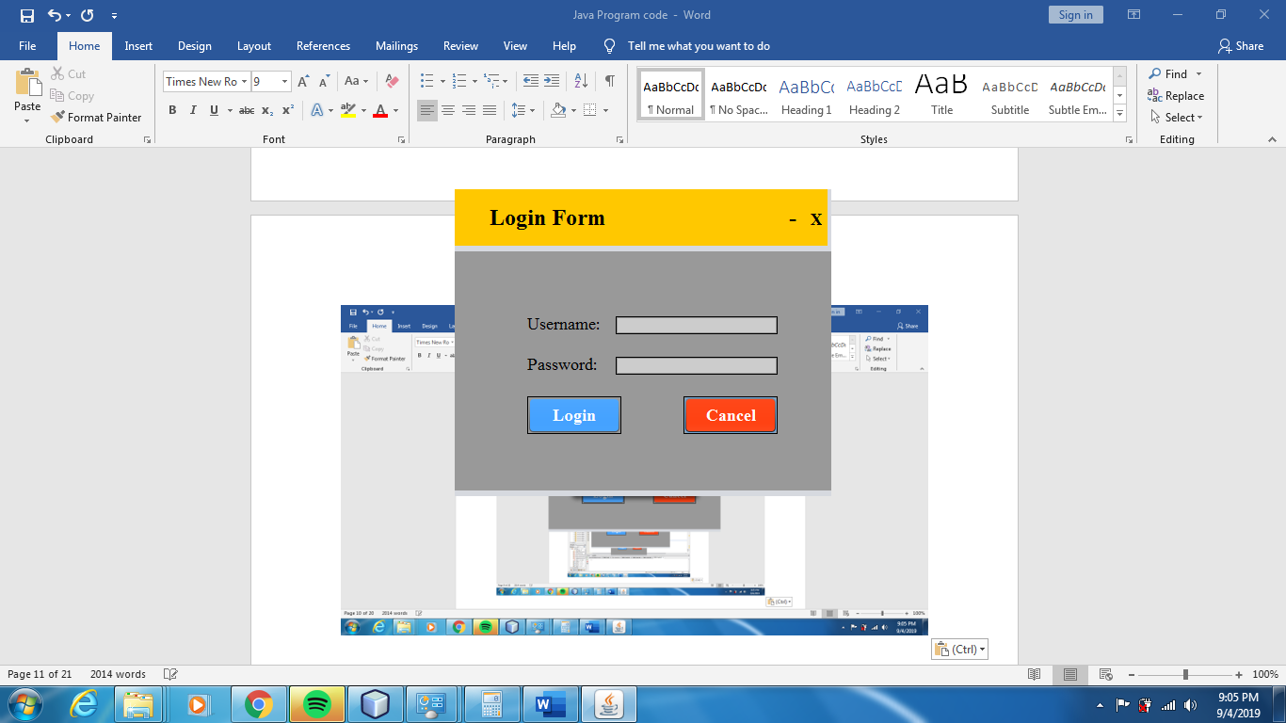

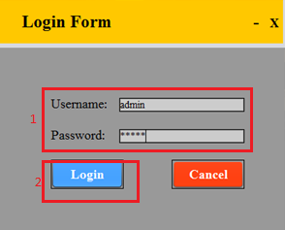

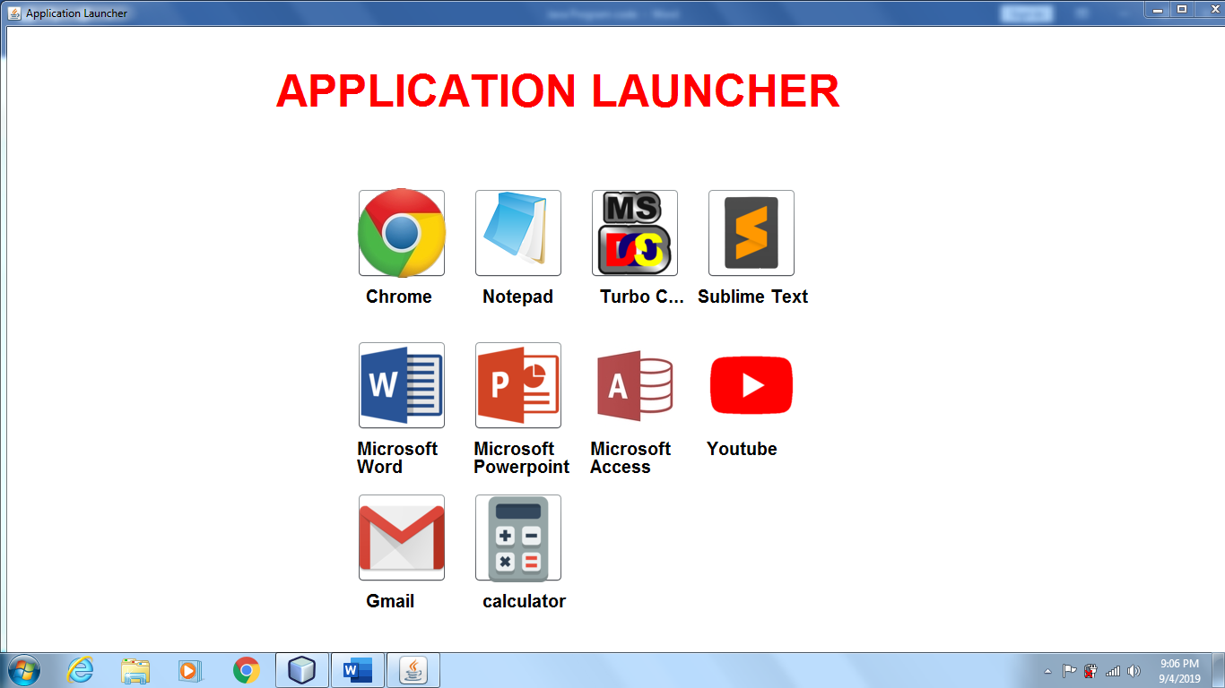

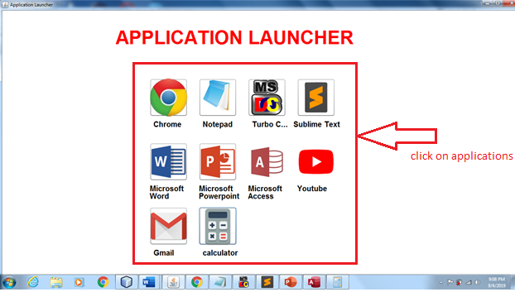

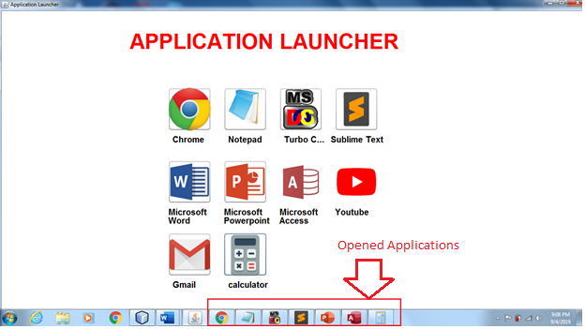

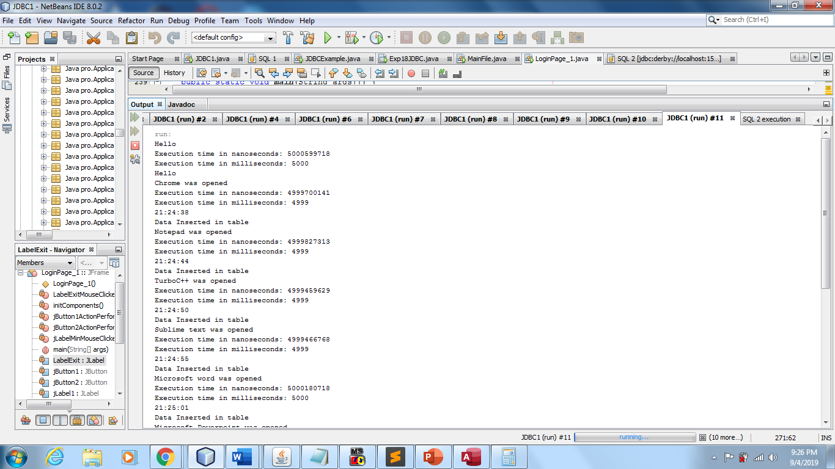

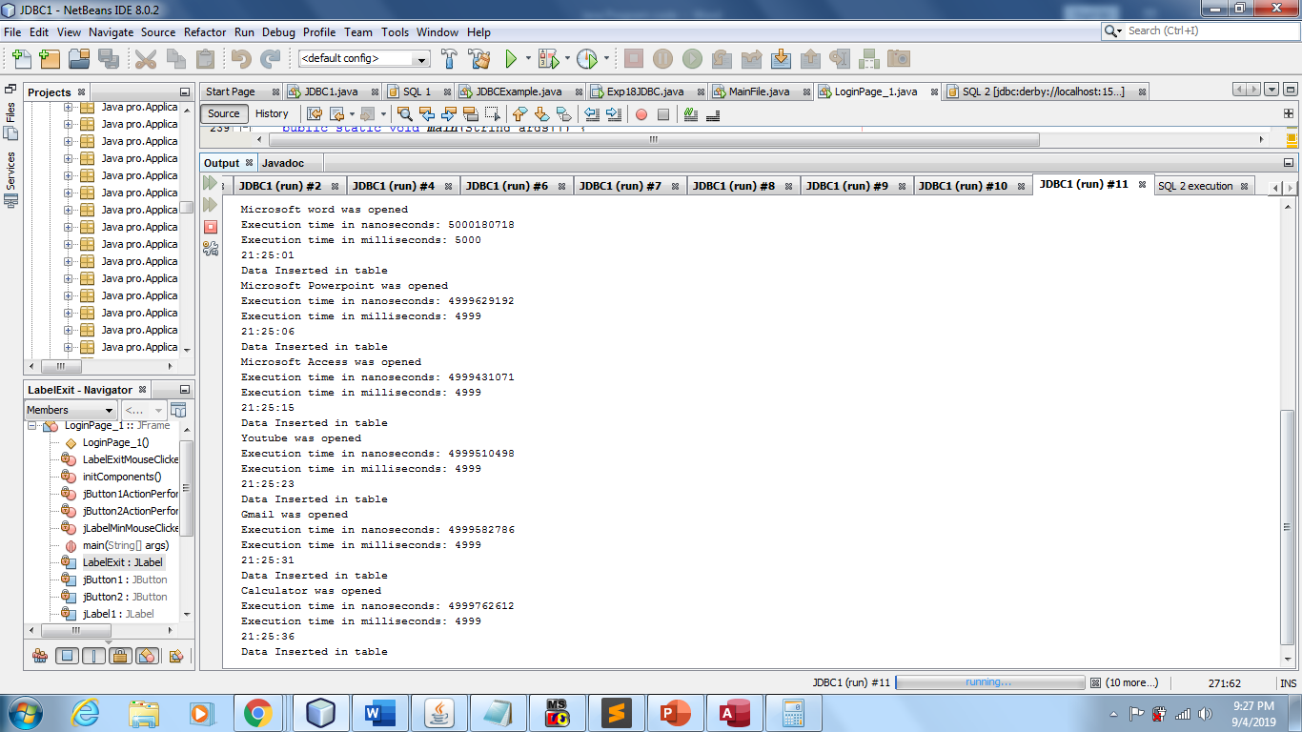

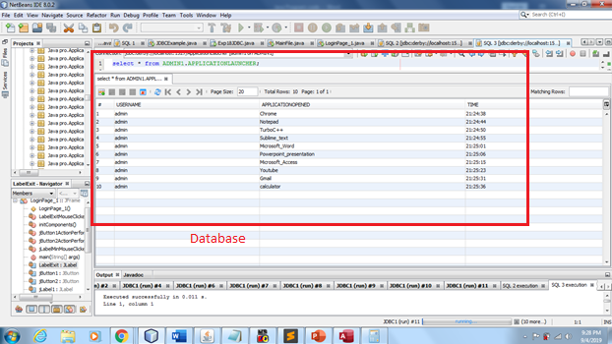

1. **Skill Developed/learning out of this Micro-Project**

The syllabus aims to develop attitudes, skills and knowledge in Java; and foster the interest in the engineering field. The knowledge includes concepts related to programming logics; and how Java works so as to use them correctly to attain the desired intent. To design, build and test java GUI, students need to be proficient with using test equipment, building interface and performing testing.

The willingness, mental strength and confidence to take on challenges and setbacks are key traits of the syllabus aims to develop attitudes, skills and knowledge in programming; and foster the interest in the engineering field.

The willingness, mental strength and confidence to take on challenges and setbacks are key traits of a successful engineer. The teaching strategies adopted should effectively be delivering these goals of a successful engineer. The teaching strategies adopted should effectively be delivering these goals.

**Micro-Project Evaluation Sheet**

|  |  |  |  |  |
| --- | --- | --- | --- | --- |
| Process Assessment | | Product Assessment | | Total Marks  10 |
| Part A –Project Proposal  (2 marks) | Project Methodology  (2 marks) | Part B-Project Report /working model  (2 marks) | Individual Presentation /Viva  (4 marks) |  |
|  |  |  |  |  |

Note:

Every course teacher is expected to assign marks for group evolution in first 3 columns and individual evaluation in 4th columns for each group of student as per rubrics.

Comments/Suggestion about team work/leadership/inter-personal communication (if any)

……………………………………………………………………………………………….

……………………………………………………………………………………………….

……………………………………………………………………………………………….

Any Other Comment:

…………………………………………………………………………………………………………..

……………………………………………………………………………………………………………..

Name and designation of the Faculty Member………………………………………………………………………………………

Signature……………………………………………………………………………………………………………………………………………….